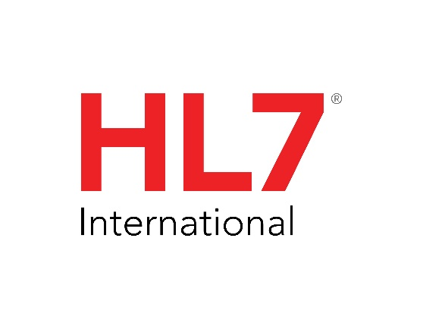V291_R1_N1_2022SEP

# Control: Conformance

2

|  |  |
| --- | --- |
| Chapter Chair | Frank Oemig Deutsche Telekom Healthcare Security Solutions GmbH |
| Chapter Chair | Robert Snelick National Institute of Standards and Technology (NIST) |
| Chapter Chair | Ioana Singureanu |
| Chapter Chair | Nathan Bunker American Immunization Registry Assoication (AIRA) |
| Sponsoring Work Group: | Conformance |
| List Server: | [cgit@lists.hl7.org](mailto:cgit@lists.hl7.org) |

For v2.9.1, the contents of Chapter 2b have been superseded by the [HL7 Version 2 Conformance Methodology Release 1.](https://www.hl7.org/implement/standards/product_brief.cfm?product_id=533)